Experiment 10 (On-line version)

WAVES
- EQUIPMENT
2 long springs (slinky and coiled spring)  Meter stick | WAVE program  Stopwatch

INTRODUCTION
The purpose of this experiment is to investigate the properties of two types of waves, the superposition of waves, and the principle of standing waves.

      - Longitudinal and Transverse Waves
These are two general types of waves transverse and longitudinal. Waves on a string are an example of transverse waves. Light and radio waves are also examples of transverse waves. Sound waves, on the other hand, are an example of longitudinal waves. Consider sound waves traveling through the air. The sound waves consist of areas of compression, where the air density is greater, and rarefaction, where the air density is reduced. It is not the air itself but rather a pulse of energy moving through the air that produces sound waves. Of course, sound waves can be heard and felt, but not seen.

Wave Superposition
When two or more waves meet, they add together to produce a different waveform. Complex waves, those that are not of a pure tone or single frequency, are made from the superposition, or addition, of several other waves. Your voice, waves on a string, and some electrical waves are examples of complex waves. You will use a computer program to observe how complex waves are produced. The simulation program allows you to choose the characteristics of two waves which are to be superimposed. The computer then shows the two original waveforms and the result of their addition.

Standing Waves
Standing waves are a special example of wave interference. If two sets of waves having equal amplitude and wavelength pass through one another in opposite directions, the waves produce areas of constructive and destructive interference that can be observed as positions of maximum and minimum vibration. These positions are referred to as antinodes and nodes respectively.

By vibrating a length of string that is fixed at one end, a train of transverse waves will be sent down the string and then reflected back. If the tension in the string is adjusted, standing waves can be set up in the string. The number of standing waves produced is determined not only by the tension in the string but also the mass per unit length of the string and the vibrating frequency. This demonstration will use a driver to produce an incident wave train along a string fixed at one end. Tension in the fixed end is produced by suspended masses. By varying the tension, different numbers of standing waves can be produced.

As noted above, standing waves are characterized by nodes and antinodes. In the case of the vibrating string, nodes are points on the string where no vibration is apparent. At these points there is no displacement of the string. Antinodes are points of maximum vibration and displacement of the string.

See video below for an explanation of standing waves.

https://www.youtube.com/watch?v=-gr7KmTOrx0

PROCEDURE

To collect data for this part (A) of the lab you will need to look at two YouTube videos.

A. Longitudinal and Transverse Waves

For steps 1 and 2 look at this video.

https://www.youtube.com/watch?v=1QhOjTaQaGE
- Attach a piece of tape to a single coil of a spring, about one or two feet from the end, and stretch the spring along a smooth floor with you at one end and your partner at the other.
- While your partner holds one end still, reach a short distance down the spring’s length and gather the coils toward you. Quickly release the gathered coils. Repeat this several times and then let your partner try it. Notice the direction in which the pulse travels and the direction in which the coils of the spring move. Pay special attention to how the piece of tape behaves as the longitudinal pulse goes through the spring. See video below.

For steps 3 through 7 see this video

https://www.youtube.com/watch?v=SCtf-z4t9L8

- Continue producing longitudinal pulses and observe the speed of the pulse as it travels down the length of the spring. Vary the speed of the pulse by changing the tension in the spring.
- While your partner holds one end of the spring still, “move’ the spring sideways very quickly. Do this until you are able to send a transverse pulse shaped like a hump down the length of the spring. Observe the motion of the coils and the piece of tape as the pulse travel through the spring. Observe the speed of the transverse pulse. Vary the speed of the pulse by changing the tension in the spring.
- Send a transverse pulse down spring as in Step 4, but pay special attention to how the pulse behaves when it reaches the end of the spring held stationary by your partner. (Notice whether the pulse inverts or remains the same).
Q1: See data sheet to answer question 1 now.
- Send a transverse pulse down your end of the spring at the same time as your partner. Try sending a transverse pulse from the same side and from opposite sides. Observe what happens when the pulses meet along the spring.
Q2. See data sheet to answer question 2 now.
- In this part of the lab you will measure the speed of a wave pulse by timing the time it takes for a wave pulse (either longitudinal or transverse) to travel two round trips over a known distance.
Got to the part of the video where the presenter increases the tension on the spring. Approximately at the 2:00 (2 minute) mark.
Using a stop watch record the time it takes for two round trips. Be sure and record in the table the start time you used since there are more than one set of round trips on video.
Since speed is defined as total distance of two round trips (20 ft * 2*2 = 80 ft) divided by total time (of two round trips) the speed of the wave is 80 ft divided by total time (you recorded using stopwatch)
Q3. See data sheet to answer question 3 now.
You have observed that the speed of a wave depends on the medium (the spring with different tension is another medium).

      - B. Wave Computer Simulation

The application Wave Addition Interactive allows you to simulate and view the motion of either a single wave or two waves and then to the combine them and view the result of wave addition or superposition. Click on the link below to open the simulation.
https://www.physicsclassroom.com/Physics-Interactives/Waves-and-Sound/Wave-Addition/Wave-Addition-Interactive
- You should now see something that looks like this:
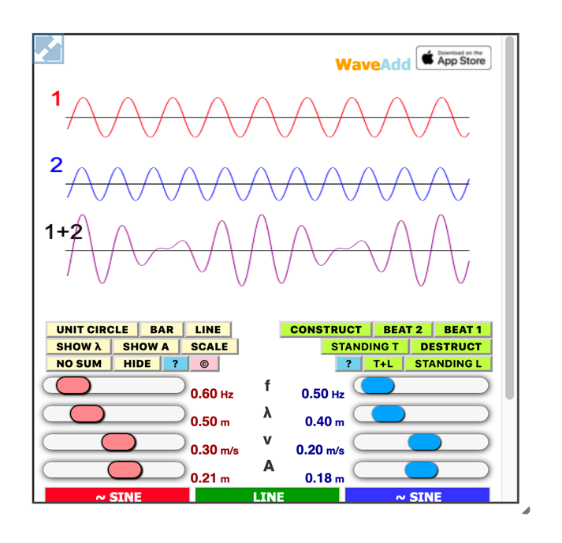
Follow directions to change the size to a more convenient or preferred size.

- You should now see moving two waves (wave 1 & wave 2) with different properties and their sum (wave 1+2).
- In the bottom portion of the simulation you can see the sliders which you can use to vary the properties of each wave. Please note that there is a STOP button that is quite useful.

Explore the 4 characteristics that you can change (frequency f, wavelength λ, velocity v and amplitude A). Make a change to one characteristic at a time and observe what you see.
When varying the characteristics of the wave the most obvious thing you should notice is that for a constant velocity, if you change either wavelength or frequency the other property changes also. That is because of the relationship
velocity is equal to wavelength * frequency, or

$v= λf$.

You should also notice that changing the amplitude does not affect the other properties.
Q4: See data sheet to answer question 4 now.

Experiment 10

DATA SHEET
Name:
Section:
QUESTIONS:
PART A
1:
                - Describe the motion of the tape as longitudinal pulses traveled through the spring. Compare its motion to that of the direction of the pulse along the spring. What happened to the pulse when it reached the stationary end of the spring?

                - Describe the motion of the tape as transverse pulses traveled through the spring. Compare its motion to that of the direction of the pulse along the spring. What happened to the pulse when it reached the stationary end of the spring?

2: How did the two pulses produced at opposite ends behave when they met along the spring? Elaborate on the fact that there are two possible conditions. Illustrate this with a diagram for each.

3: How did you vary the speed of the pulses in the spring?

Table for Part A. # 7
Start time on video  used to time round trips | Round Trip Distance  (ft)  (20 ft * 2*2) | Trial 1  Time for 2 round  Trips  (s) | Trial 2  Time for 2 round  Trips  (s) | Trial 3  Time for 2 round  Trips  (s) | Average time of 3 trials  (s) | Velocity of Wave  (ft/s)  column 2 ÷ column 6  (s)
 | 80

PART B (To be completed using wave simulation software)
4: The velocity of a wave is a property of the medium. For a wave propagating in a uniform medium the velocity of a wave will not change. We know that velocity is equal to wavelength * frequency .
To answer the following you need only to look at one wave. You may set one wave’s amplitude to zero.

Set the velocity to some non-zero value. Using the wave property sliders, vary (one at a time) the wave length, frequency and amplitude.

What affect does changing each of these properties (individually) have on the wave form?

Amplitude: ______________

Wavelength: ______________

frequency: _______

5: When the velocity is negative, which direction does a wave travel? ____________

When the velocity is positive, which direction does the wave travel? ____________

6: If the wavelength of a wave is 50 m and it is moving at 350 m/s, what is its frequency? _____________. Show work. Use $v= λf$

For question 7 below click on “SCALE” and “CONSTRUCT” 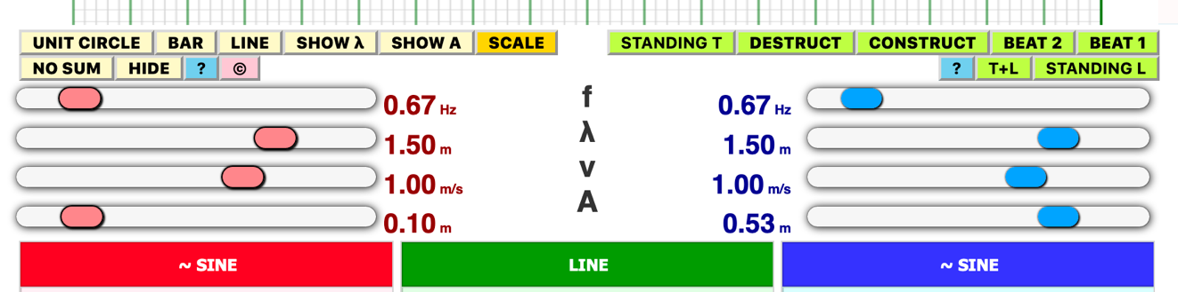

7: a. Draw a graph of the 2 identical waves and their resultant wave when the peaks of the 2 waves coincide.

You will need to stop waves to draw them. Hit “STOP” button which is located below the “LINE” heading.

See section 19.5 (page 363) of text if you need help with diagrams.

            - Draw a graph of the 2 identical waves and their resultant wave when the 2 waves pass peak to valley.

Click on the “DESTRUCT” button to answer part b below.

8: What happens when two waves differing only in amplitude are superposed? Click on “CONSTRUCT” and “STOP” to begin

Set the amplitude A of one of the waves (only) to your section number dived by 10 (e.g., if you are in section one (1) set the amplitude of one wave to 0.1 m. If you are in section 8 (set amplitude to 0.3 m).

Illustrate this with a diagram.

9: What happens when two waves with equal frequencies and amplitudes and a phase angle difference of 180° are superimposed? Illustrate this with a diagram.

10: You will now examine and compare the behavior of both transverse and longitudinal of standing waves.

                - What the conditions that define a standing wave? See section 19.5 of text for help.

                - Click on the “STANDING T” button to see a transverse standing wave- .
What do you observe about the speed, velocity, wavelength and amplitude of the two waves?

                - Click on the “STANDING L” button to see at transverse longitudinal wave. =>
Compare the similarities and the differences between a longitudinal standing wavs and the transverse standing wave.

